Sprint 1 Plan

Personal Knowledge Engine (PKE)

Sprint Completion 10/19/21

Revision 2 10/23/21

**Goal:**

The goal of this sprint is to implement basic file/directory search capabilities.

**User Stories:**

**-As a student, I want to be able to search through a single file for keywords so I can find important information.**

Task 1: Implement a function that takes in as parameters a file name/path and the string to search for and returns a list of lines where the string is found. (2)

**-As a student/teacher, I want to be able to search through multiple files for keywords, so I don’t have to search files individually.**

Task 1: Implement a function to search through multiple files in the given directory for a given string. (2)

**-As a user, I want to be able to restrict my search to certain file types, or to specific folders, so the search is quicker.**

Task 1: Implement a function that takes in directories to include/exclude and extensions to include as parameters to filter the search criteria. (3)

**Team Roles:**

Noah Cantwell – Scrum master

Weston Cook – Product owner

Anupreet Singh – Developer

Rodger Wang – Developer

Cole Anderson – Developer

Jason Zheng – Developer

**Initial Task Assignment:**

Cole Anderson - As a student, I want to be able to search through a single file for keywords so I can find important information. (Task 1)

Noah Cantwell - As a student/teacher, I want to be able to search through multiple files for keywords, so I don’t have to search files individually. (Task 1)

Weston Cook - As a user, I want to be able to restrict my search to certain file types, or to specific folders, so the search is quicker. (Task 1)

Anupreet Singh – Research for next sprint

Rodger Wang – Research for next sprint

Jason Zheng – Research for next sprint

**Initial Burnup Chart:**

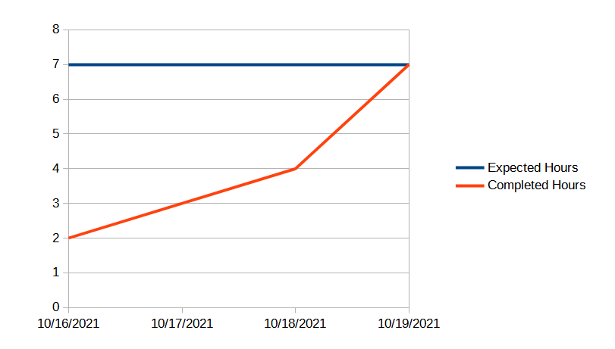

**Initial Scrum Board:**

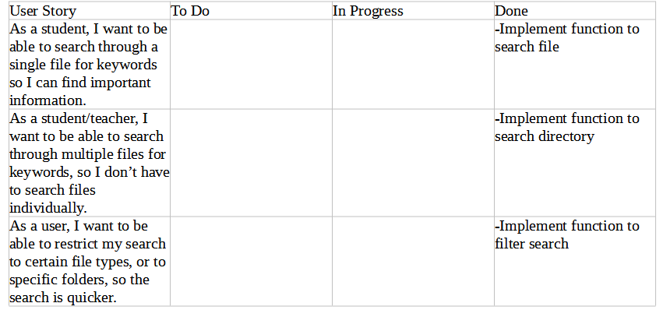

**Scrum Times:**

Monday: 3:00-4:00 pm

Wednesday: 8:30-9:30 pm

Saturday: 4:00-5:00 pm